1. Given an array of strings words, return the first palindromic string in the array. If there is
no such string, return an empty string "". A string is palindromic if it reads the same
forward and backward.
Example 1:
Input: words = ["abc","car","ada","racecar","cool"]
Output: "ada"
Explanation: The first string that is palindromic is "ada".
Note that "racecar" is also palindromic, but it is not the first.
Example 2:
Input: words = ["notapalindrome","racecar"]
Output: "racecar"
Explanation: The first and only string that is palindromic is "racecar".
CODE:
def firstPalindrome(words):
for word in words:
if word == word[::-1]:
return word
return ""
words1 = ["abc","car","ada","racecar","cool"]
print(firstPalindrome(words1))
words2 = ["notapalindrome","racecar"]
print(firstPalindrome(words2))

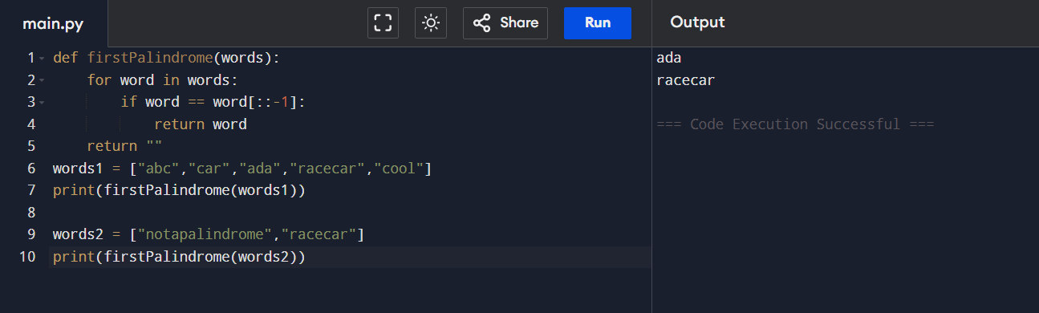
2. You are given two integer arrays nums1 and nums2 of sizes n and m, respectively.
Calculate the following values: answer1 : the number of indices i such that nums1[i]
exists in nums2. answer2 : the number of indices i such that nums2[i] exists in nums1
Return [answer1,answer2].
Example 1:
Input: nums1 = [2,3,2], nums2 = [1,2]
Output: [2,1]
Explanation:
Example 2:
Input: nums1 = [4,3,2,3,1], nums2 = [2,2,5,2,3,6]
Output: [3,4]
Explanation:
The elements at indices 1, 2, and 3 in nums1 exist in nums2 as well. So answer1 is 3.
The elements at indices 0, 1, 3, and 4 in nums2 exist in nums1. So answer2 is 4.
CODE:
def findIntersectionValues(nums1, nums2):
set1 = set(nums1)
set2 = set(nums2)
answer1 = sum(1 for x in nums1 if x in set2)
answer2 = sum(1 for x in nums2 if x in set1)
return [answer1, answer2]
nums1 = [2, 3, 2]
nums2 = [1, 2]
print(findIntersectionValues(nums1, nums2))
nums1 = [4, 3, 2, 3, 1]
nums2 = [2, 2, 5, 2, 3, 6]
print(findIntersectionValues(nums1, nums2))
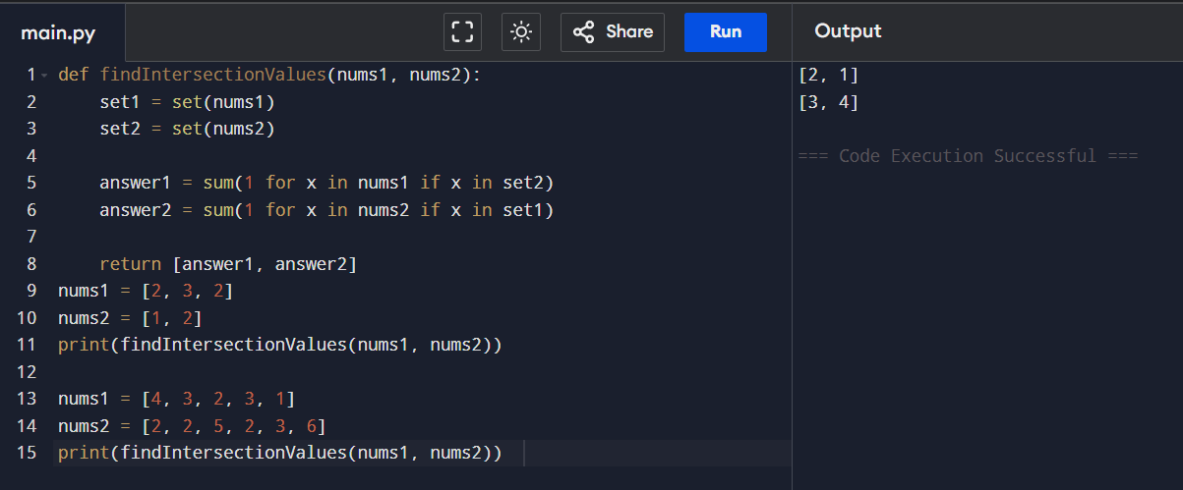
3. You are given a 0-indexed integer array nums. The distinct count of a subarray of nums is
defined as: Let nums[i..j] be a subarray of nums consisting of all the indices from i to j
such that 0 <= i <= j < nums.length. Then the number of distinct values in nums[i..j] is
called the distinct count of nums[i..j]. Return the sum of the squares of distinct counts of
all subarrays of nums. A subarray is a contiguous non-empty sequence of elements within
an array.
Example 1:
Input: nums = [1,2,1]
Output: 15
Explanation: Six possible subarrays are:
[1]: 1 distinct value
[2]: 1 distinct value
[1]: 1 distinct value
[1,2]: 2 distinct values
[2,1]: 2 distinct values

[1,2,1]: 2 distinct values
The sum of the squares of the distinct counts in all subarrays is equal to 12 + 12 + 12 +
22 + 22 + 22 = 15.
Example 2:
Input: nums = [1,1]
Output: 3
Explanation: Three possible subarrays are:
[1]: 1 distinct value
[1]: 1 distinct value
[1,1]: 1 distinct value
The sum of the squares of the distinct counts in all subarrays is equal to 12 + 12 + 12 = 3.
CODE:
def sumCounts(nums):
n = len(nums)
total = 0
for i in range(n):
seen = set()
for j in range(i, n):
seen.add(nums[j])
distinct_count = len(seen)
total += distinct_count ** 2
return total
print(sumCounts([1, 2, 1]))
print(sumCounts([1, 1]))

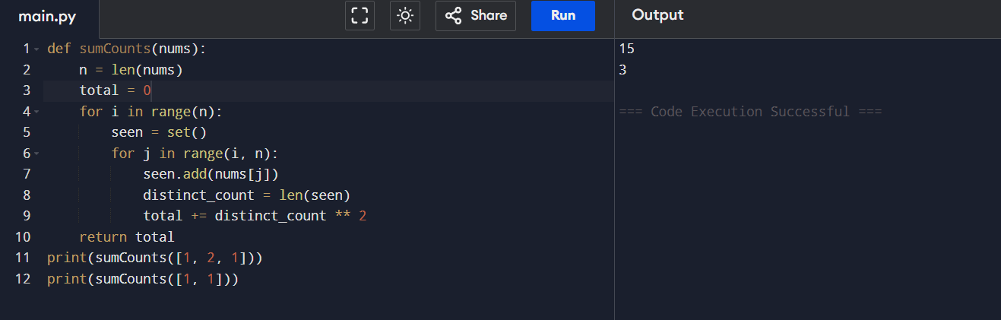

4. Given a 0-indexed integer array nums of length n and an integer k, return the number of
pairs (i, j) where 0 <= i < j < n, such that nums[i] == nums[j] and (i * j) is divisible by k.
Example 1:
Input: nums = [3,1,2,2,2,1,3], k = 2
Output: 4
Explanation:
There are 4 pairs that meet all the requirements:
- nums[0] == nums[6], and 0 * 6 == 0, which is divisible by 2.
- nums[2] == nums[3], and 2 * 3 == 6, which is divisible by 2.
- nums[2] == nums[4], and 2 * 4 == 8, which is divisible by 2.
- nums[3] == nums[4], and 3 * 4 == 12, which is divisible by 2.
Example 2:
Input: nums = [1,2,3,4], k = 1
Output: 0
Explanation: Since no value in nums is repeated, there are no pairs (i,j) that meet all the
requirements.
CODE:
def countPairs(nums, k):
n = len(nums)
count = 0
for i in range(n):
for j in range(i + 1, n):
if nums[i] == nums[j] and (i * j) % k == 0:
count += 1
return count
print(countPairs([3,1,2,2,2,1,3], 2))
print(countPairs([1,2,3,4], 1))

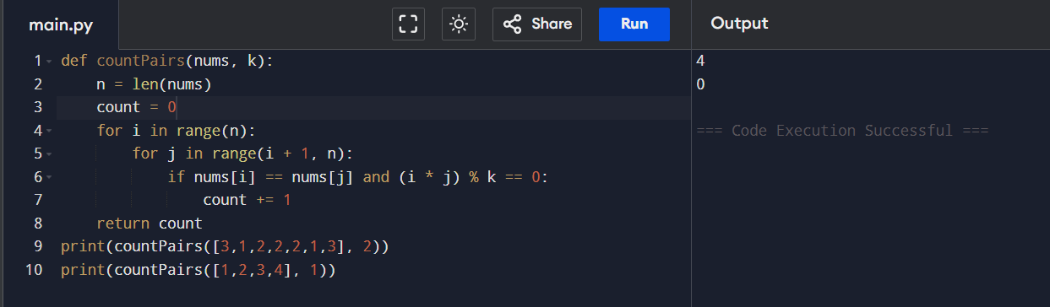
5. Write a program FOR THE BELOW TEST CASES with least time complexity
Test Cases: -
1) Input: {1, 2, 3, 4, 5} Expected Output: 5
2) Input: {7, 7, 7, 7, 7} Expected Output: 7
3) Input: {-10, 2, 3, -4, 5} Expected Output: 5
CODE:
def find_max(nums):
max_val = nums[0]
for num in nums:
if num > max_val:
max_val = num
return max_val
print(find_max([1, 2, 3, 4, 5]))
print(find_max([7, 7, 7, 7, 7]))
print(find_max([-10, 2, 3, -4, 5]))

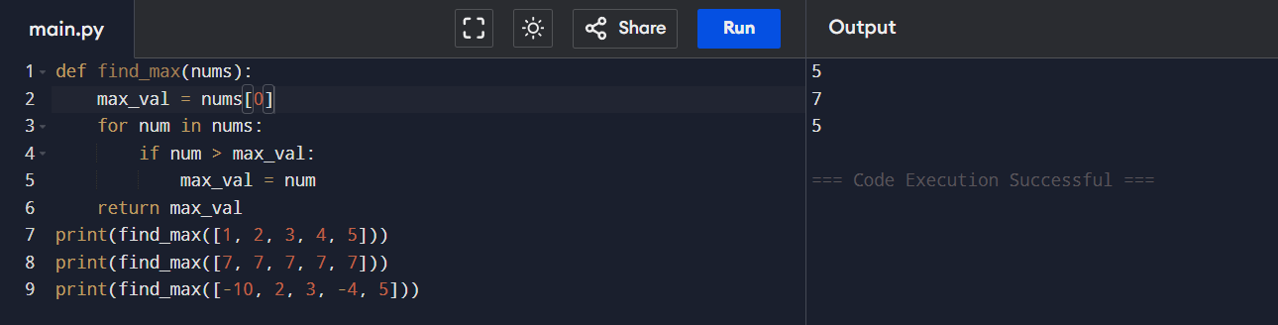

6. You have an algorithm that process a list of numbers. It firsts sorts the list using an
efficient sorting algorithm and then finds the maximum element in sorted list. Write the
code for the same.
Test Cases
1. Empty List
1. Input: []
2. Expected Output: None or an appropriate message indicating that the list
is empty.
2. Single Element List
1. Input: [5]
2. Expected Output: 5

3. All Elements are the Same
1. Input: [3, 3, 3, 3, 3]
2. Expected Output: 3
CODE:
def find_max_after_sort(nums):
if not nums:
return None
nums.sort() # efficient sorting (Timsort: O(n log n))
return nums[-1]
print(find_max_after_sort([]))
print(find_max_after_sort([5]))
print(find_max_after_sort([3,3,3,3,3]))
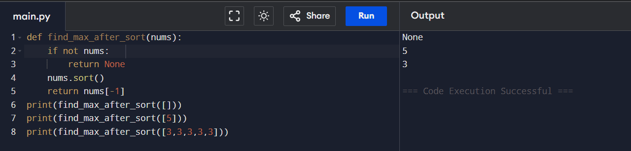
7. Write a program that takes an input list of n numbers and creates a new list containing
only the unique elements from the original list. What is the space complexity of the
algorithm?
Test Cases
Some Duplicate Elements
• Input: [3, 7, 3, 5, 2, 5, 9, 2]
• Expected Output: [3, 7, 5, 2, 9] (Order may vary based on the algorithm used)
Negative and Positive Numbers
• Input: [-1, 2, -1, 3, 2, -2]
• Expected Output: [-1, 2, 3, -2] (Order may vary)
List with Large Numbers
• Input: [1000000, 999999, 1000000]
• Expected Output: [1000000, 999999]
CODE:
def unique_elements(nums):
unique_list = []
seen = set()
for num in nums:
if num not in seen:
unique_list.append(num)
seen.add(num)
return unique_list
print(unique_elements([3,7,3,5,2,5,9,2]))
print(unique_elements([-1,2,-1,3,2,-2]))
print(unique_elements([1000000,999999,1000000]))
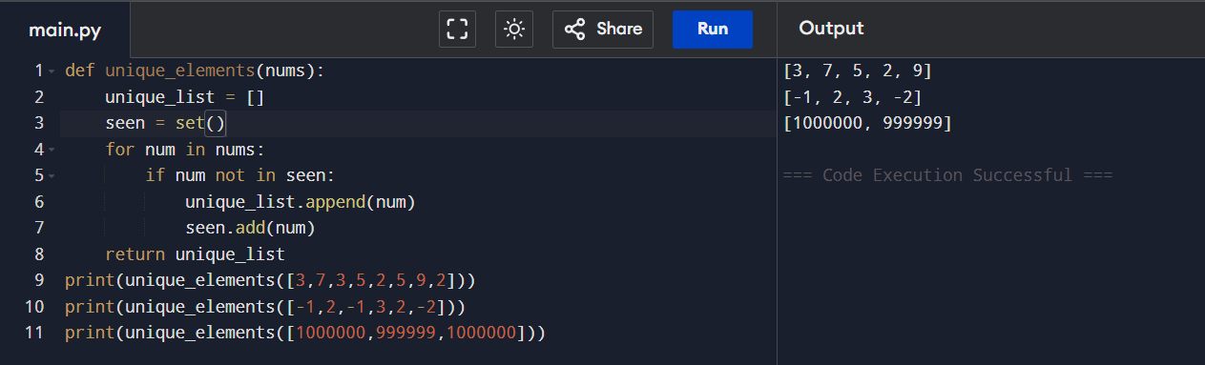
8. Sort an array of integers using the bubble sort technique. Analyze its time complexity
using Big-O notation. Write the code
CODE:
def bubble_sort(arr):
n = len(arr)
for i in range(n):
for j in range(0, n - i - 1):
if arr[j] > arr[j + 1]:
# swap
arr[j], arr[j + 1] = arr[j + 1], arr[j]
return arr
print(bubble_sort([5, 2, 9, 1, 5, 6]))

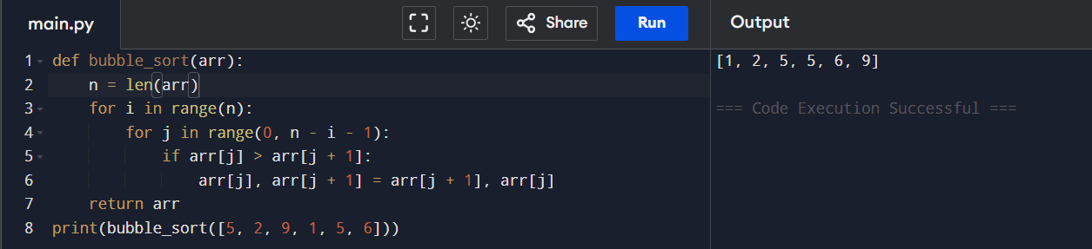
9. Checks if a given number x exists in a sorted array arr using binary search. Analyze its
time complexity using Big-O notation.
Test Case:
Example X={ 3,4,6,-9,10,8,9,30} KEY=10
Output: Element 10 is found at position 5
Example X={ 3,4,6,-9,10,8,9,30} KEY=100
Output : Element 100 is not found
CODE:
def binary_search(arr, key):
arr.sort()
low = 0
high = len(arr) - 1
while low <= high:
mid = (low + high) // 2
if arr[mid] == key:
return mid
elif arr[mid] < key:
low = mid + 1
else:
high = mid - 1
return -1
arr = [3,4,6,-9,10,8,9,30]

key = 10
result = binary_search(arr, key)
if result != -1:
print(f"Element {key} is found at position {result}")
else:
print(f"Element {key} is not found")

key = 100
result = binary_search(arr, key)
if result != -1:
print(f"Element {key} is found at position {result}")
else:
print(f"Element {key} is not found")
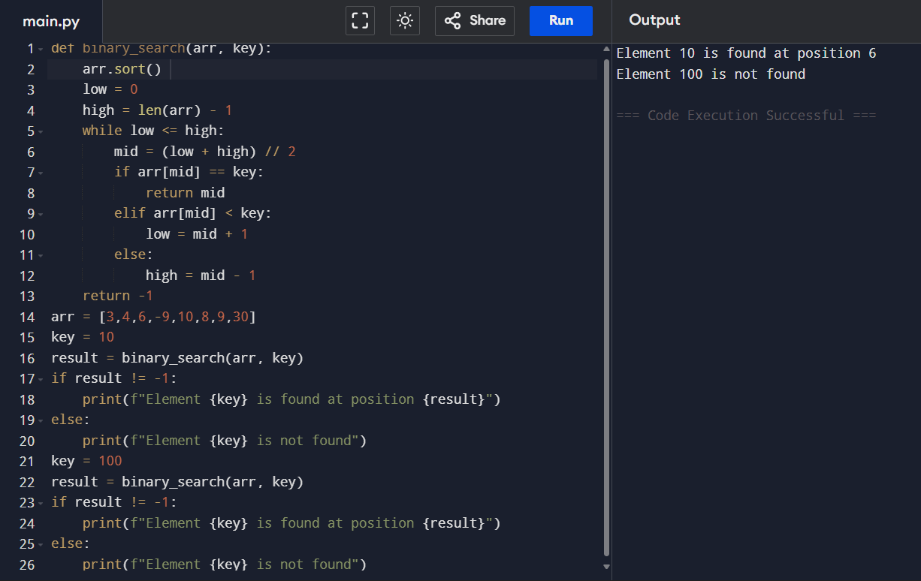
10. Given an array of integers nums, sort the array in ascending order and return it. You
must solve the problem without using any built-in functions in O(nlog(n)) time
complexity and with the smallest space complexity possible.
CODE:
def merge_sort(arr):
if len(arr) <= 1:
return arr
mid = len(arr) // 2
left = merge_sort(arr[:mid])
right = merge_sort(arr[mid:])
return merge(left, right)
def merge(left, right):
result = []
i = j = 0
while i < len(left) and j < len(right):
if left[i] < right[j]:
result.append(left[i])
i += 1
else:
result.append(right[j])
j += 1
result.extend(left[i:])
result.extend(right[j:])
return result
print(merge_sort([5, 2, 3, 1]))

